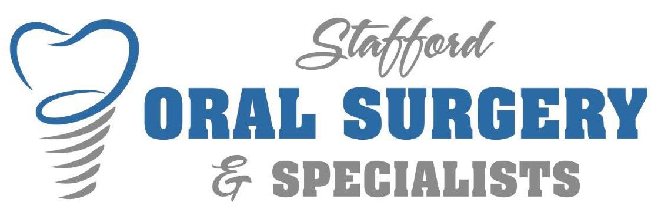

FINANCIAL POLICY

Payment Options:
- Cash, Check, Debit, Credit (Visa, Mastercard, Discover and AMEX)
- CareCredit
- In-house payment arrangements. 50% down payment required; balance paid using Automatic Recurring Billing (ARB) over the following two months.
Reschedule and Cancellation Policy
- ______ A specific amount of time is reserved exclusively for you, and we encourage all our patients to keep their appointments. If you must reschedule or cancel your appointment, we require AT LEAST TWO BUSINESS DAYS NOTICE for exam/consultation appointments to avoid a $50 cancellation fee and THREE DAYS NOTICE for all procedure or surgical appointments to avoid a $100 cancellation fee. These fees are not negotiable and are non-refundable.
Patients with Insurance: (Initial after reading each)
- ______We currently accept most PPO dental plans and are happy to work with your carrier to maximize your dental benefit. We obtain a general breakdown of coverage; however, it is impossible to give a “guaranteed” quote at the time of service. We estimate your portion based on the most up-to-date information we have. It is ONLY AN ESTIMATE and not a guarantee of payment until a final claim has been submitted and processed by your insurance company. Most insurance companies pay dental costs according to a fee schedule which they have devised. The fee schedule may or may not coincide with the actual fees that are charged. When requested by the patient, we will submit a pre-determination to the insurance company to most accurately estimate their payment. Please be advised that pre-determinations may take 30-90+ days to be processed and returned to our office.
- ______We will bill your insurance company as a courtesy. If your insurance company does not pay within 60 days, Stafford Oral Surgery & Specialists reserves the right to request payment in full for services from you and let your insurance reimburse you directly. While this is not common, it is important for you to recognize that the insurance you have is a legal contract between you and your insurance company. Ultimately you are responsible for all charges incurred by you in our office. If you have any questions regarding your dental benefits, please refer to your employer or insurance company directly.
- ______Stafford Oral Surgery does require your estimated portion of treatment to be secured at the time of service. Please refer to the payment options section. Refund checks are issued to the guarantor of the account in the event of overpayment. Every attempt will be made to refund within 90 days.
I have read, understand, and accept the terms of this Financial Policy.

Signature: _____________________________ Print _______________________ Date ______________

